**Computer science**

**PROJECT REPORT**

**GRADE – XII**

**PROJECT PREPARED BY:**

**NAME OF THE STUDENT:**

**ROLL NUMBER : ………………………………………………………..**

**PROJECT TOPIC : …………………………………................**



**HOSUR PUBLIC SCHOOL**

**2022 – 2023**

**CERTIFICATE**

This is to certify that the project work entitled **“……………………………………………………………………….”**

is a bonafide record of work done by**…………………………………… ,** Roll no:**……………….…**in partial fulfillment for the award of 12th standard during the academic year 2022 - 2023.

Date:

Registration No.:

Signature of Internal Signature of External

Examiner Examiner

Signature of Principal

# ACKNOWLEDGEMENT

I would like to take this opportunity to express my deep sense of gratitude to all those people without whom this project could have never been completed. First and foremost I like to thank God for giving me such a great opportunity to work on this project, and I would like to express my special thanks and gratitude to the Management, the Directors and the Correspondent of Hosur Public School, for their constant guidance and providing a very nice platform to learn.

I would also like to thank our Principal – Dr. V. Bindhu Hosur Public School, for her constant encouragement and moral support without which I would have never be able to give my best.

I would also like to thank Mr. A.M. Balakrishna, Computer Science Teacher, Hosur Public School, who gave me the wonderful opportunity to do this project, which also helped me in doing a lot of research and I came to know about so many new things from this study I am really thankful to all.

**Hotel management**

**INDEX**

|  |  |  |
| --- | --- | --- |
| **Sl.no** | **Topic** | **Page number** |
| **1** | **Abstract** | **1** |
| **2** | **System requirements** | **2** |
| **3** | **Feasibility study** | **3** |
| **4** | **Errors and its types** | **4** |
| **5** | **Testing** | **5** |
| **6** | **Maintenance** | **6** |
| **7** | **Purpose system** | **7-8** |
| **8** | **Source Code** | **9-19** |
| **9** | **Output** | **20-24** |
| **10** | **Conclusion** | **25** |
| **11** | **Bibliography** | **26** |

**Abstract**

* Our Hotel management is a python project done using coding.
* Our Hotel management does the functions of hotel manage such as checking availability, booking rooms, leaving reviews and reading reviews.
* The interface is user-friendly.
* If rooms are not available, you will get error message.

**SYSTEM REQUIREMENTS**

**1. HARDWARE:**

* Processor
* Keyboard
* Minimum memory - 2GB

**2. SOFTWARE:**

* Operating System –OS7, OS8
* Python IDLE

**FEASIBILITY STUDY**

Feasibility study is a system proposal according to its work, ability, impact on the operation ability to meet the needs of users and efficient use of resources. An important outcome of preliminary investigations the determination of that system requested feasible.

**ECONOMICAL FEASIBILITY:**

Economics analysis is the most frequent use method for evaluating the effectiveness of the candidates the benefits and savings that are expected from system and compare them with cost. This software is not very costly. It just worth Rs.5500/-.So users records can be maintained at a cheaper cost and every school would like to use this software so that the student’s records can be managed easily.

**TECHNICAL FEASIBILTY:**

Technical feasibility center on the existing computer system and to what extent it can support the proposed task. This involves financial consideration to accommodate technical enhancements. It is technically feasible because whatever technology is needed to develop this software is easily available.

**ERRORS AND ITS TYPES**

An error, sometime called “A BUG” is anything in the code that prevents a program from compiling and running correctly. There are broadly three types of errors as follows:

* **Compile- time errors**:

Error that occurs during compilation of a program is called compile time error. It has two types as follows: a. Syntax error: It refers to formal rules governing the construction of valid statements in a language. b. Semantics error: It refers to the set of rules which give the meaning of a statement.

* **Run time Errors**:

Error that occurs during the execution of program are run time errors. These are harder to detect errors. Some run-time error stop the execution of program which is then called program “Crashed”.

* **Logical Errors**:

Sometimes, even if you don’t encounter any error during compiling-time and runtime, your program does not provide the correct result. This is because of the programmer’s mistaken analysis of the problem he or she is trying to solve. Such errors are called logical error.

**TESTING**

1. **Alpha Testing:** It is the most common type of testing used in the software industry. The objective of this testing is to identify all possible issues or defects before releasing it into the market or to the user. It is conducted at the developer’s site.

2. **Beta Testing:** It is a formal type of software testing which is carried out by the customers. It is performed in a real environment before releasing the products into the market for the actual end-users. It is carried out to ensure that there are no major failures in the software or product and it satisfies the business requirement. Beta Testing is successful when the customer accepts the software.

3. **White Box Testing:** White box testing is based on the knowledge about the internal logic of an application’s code. It is also known as Glass box Testing. Internal Software and code working should be known for performing this type of testing. These tests are based on the coverage of the code statements, branches, paths, conditions etc.

4. **Black Box Testing:** It is a software testing, method in which the internal structure or design of the item to be tested is not known to the tester. This method of testing can be applied virtually to every level of the software testing.

**MAINTENANCE**

Programming maintenance refers to the modifications in the program. After it has been completed, in order to meet changing requirement or to take care of the errors that shown up. There are four types of maintenance:

1. **Corrective Maintenance**: When the program after compilation shows error because of some unexpected situations, untested areas such errors are fixed up by Corrective maintenance.

2. **Adaptive Maintenance**: Changes in the environment in which an information system operates may lead to system management. To accommodate changing needs time to time maintenance is done and is called Adaptive maintenance.

3. **Preventive Maintenance**: If possible the errors could be anticipated before they actually occur; the maintenance is called Preventive maintenance.

4. **Perfective Maintenance**: In this rapidly changing world, information technology is the fastest growing area. If the existing system is maintained to keep tuned with the new features, new facilities, new capabilities, it is said to be Perfective maintenance.

**Proposed system**

All the four activities of systems have been automated and efforts have been made to minimize the manual working.

**Benefits Of Purposed System:-**

1. **Less Paper Work**

The paper work is reduced to minimal level. Computer prepares the lists of

customers.

1. **No Manual Work.**

There is no manual work. All the processes are done through computer.

1. **Flexibility**

The system is more flexible than the manual system being used presently.

1. **Beneficial**

The system is easy to use and reduces the user’s workload a lot. It provides timely

and accurate information and there is automatic generation of reports.

**Code**

**import pandas as pd**

**rooms_cost = {"Dulex Suite": 1000, "King  Suite": 3000, "Queen Suite": 2000}**

**rooms_available = {"Dulex Suite": 10, "King  Suite": 10, "Queen Suite": 10}**

**reviews = []**

**bookings = []**

**def get_availability() -> None:**

**for key in rooms_available:**

**print("Room: {}   Availability: {}   Room Cost: {}".format(key, rooms_available[key], rooms_cost[key]))**

**print("**************************")**

**print("---Welcome to Taj Hotel---")**

**print("**************************")**

**while True:**

**print("**************************")**

**response = input(**

**'What would you like do: \nCheck Availability__(A) \nBook A Room_________(B) \nLeave A Review______(L) \nRead Reviews________(R) \nQuit________________(Q) \n: '**

**).lower()**

**print("**************************")**

**valid_responses = ['a', 'b', 'c', 'l', 'q']**

**if response == 'a':**

**print("**************************")**

**print("Please find the available rooms:")**

**get_availability()**

**print("**************************")**

**elif response == 'b':**

**print("********************************")**

**print("Please find the available rooms:")**

**room_selection = 'Please select room '**

**no_rooms = 0**

**for key in rooms_available:**

**rooms = rooms_available[key]**

**no_rooms = no_rooms + rooms**

**if rooms > 0:**

**if key == 'Dulex Suite':**

**room_selection = room_selection + " Dulex(D)/"**

**elif key == 'King  Suite':**

**room_selection = room_selection + " King(K)/"**

**else:**

**room_selection = room_selection + " Queen(Q)/"**

**if no_rooms == 0:**

**print("Sorry no rooms available.")**

**room_type = input(room_selection + ': ').lower()**

**if room_type == 'd':**

**rooms_available["Dulex Suite"] = rooms_available["Dulex Suite"] - 1**

**name = input("Enter your name: ")**

**emailid = input("Enter emailid: ")**

**bookings.append([name, emailid, "Dulex Suite"])**

**print("You have successfully booked a room {}. Thanks for choicing Taj.".format(name))**

**elif room_type == 'k':**

**rooms_available["King  Suite"] = rooms_available["King  Suite"] - 1**

**name = input("Enter your name: ")**

**emailid = input("Enter emailid: ")**

**bookings.append([name, emailid, "King  Suite"])**

**print("You have successfully booked a room {}. Thanks for choicing Taj.".format(name))**

**elif room_type == 'q':**

**rooms_available["Queen Suite"] = rooms_available["Queen Suite"] - 1**

**name = input("Enter your name: ")**

**emailid = input("Enter emailid: ")**

**bookings.append([name, emailid, "Queen Suite"])**

**print("You have successfully booked a room {}. Thanks for choicing Taj.".format(name))**

**else:**

**print("Sorry invalid room selection, lets start over.")**

**print("********************************")**

**elif response == 'l':**

**print("********************************")**

**print("Your review is appreciated:")**

**name = input("Enter name: ")**

**emailid = input("Enter emailid: ")**

**comment = input("Enter Review: ")**

**reviews.append([name, emailid, comment])**

**print("Thanks for your review. Our team will reach out to you.")**

**print("********************************")**

**elif response == 'r':**

**print("********************************")**

**print("Reviews: ")**

**for review in reviews:**

**print("Name: ", review[0])**

**print("Emailid: ", review[1])**

**print("Review: ", review[2])**

**print("End of reviews.")**

**print("********************************")**

**elif response == 'q':**

**print("*************************************************")**

**print("Thanks visiting us. Hope we can service you soon.")**

**print("*************************************************")**

**exit()**

**else:**

**print("Sorry invalid choice selected, lets start over.")**

**Output**

1. View Options:

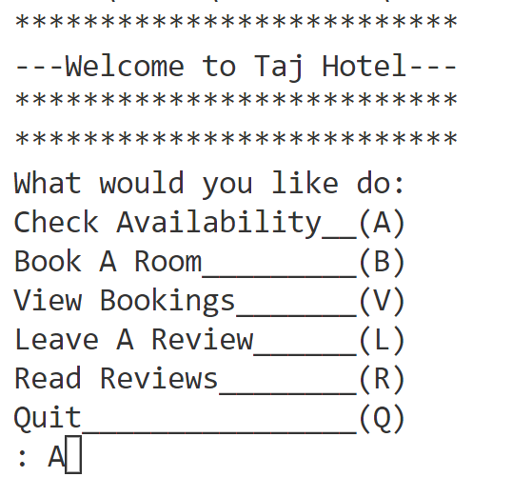

1. Checking availability:

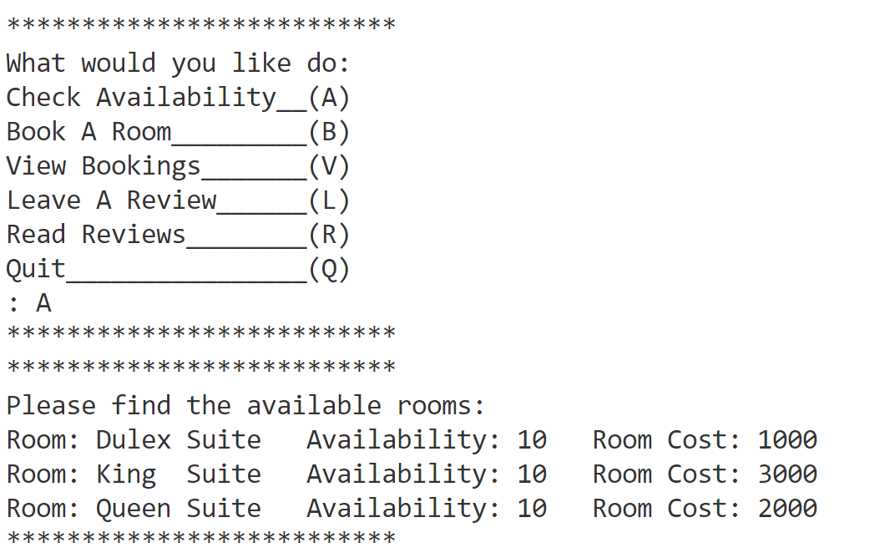

1. Booking a room:

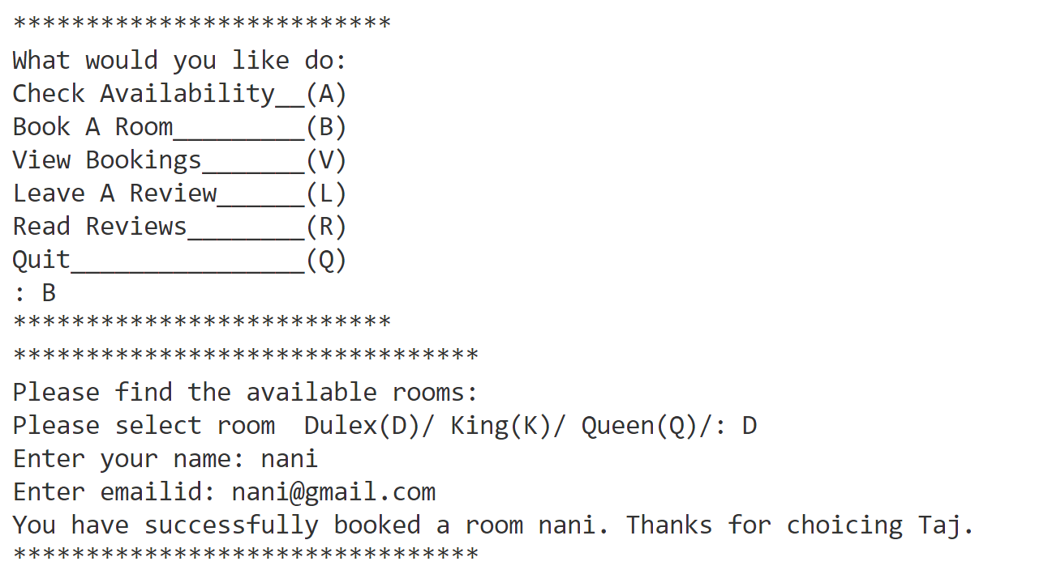

1. No Rooms available:

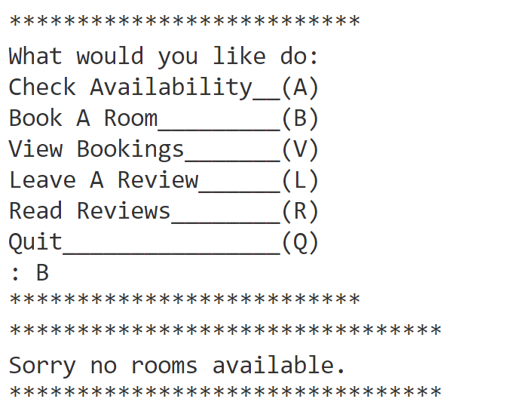

1. Leaving a review:

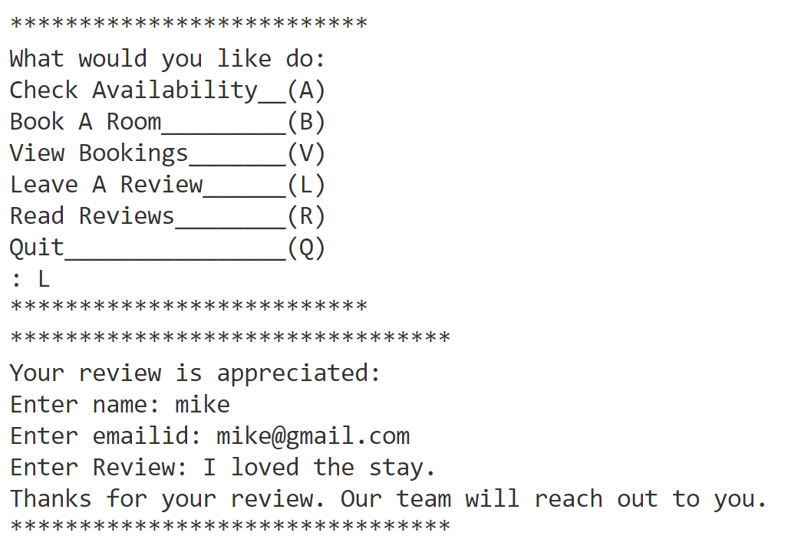

1. Reading reviews:

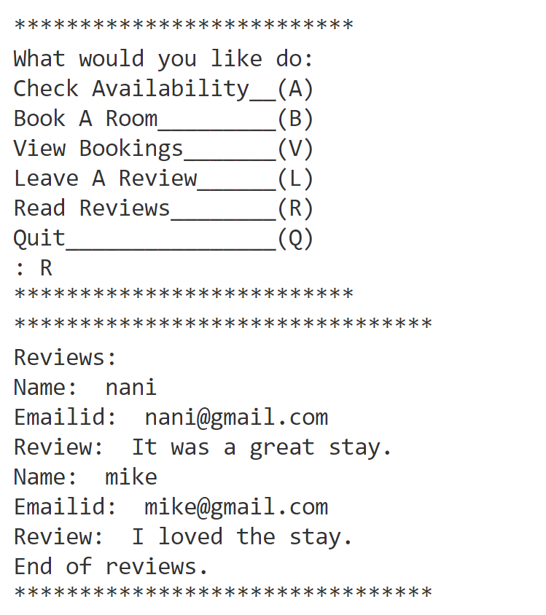

1. Reading Bookings:

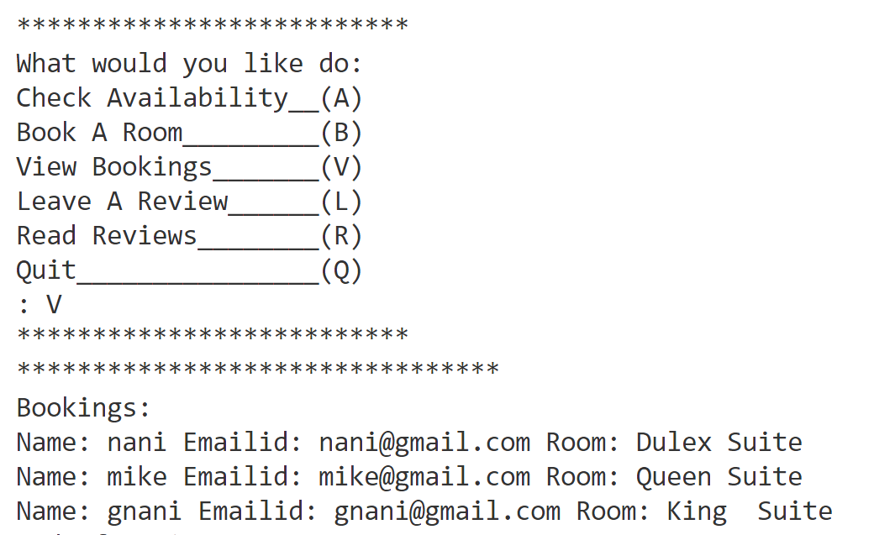

1. Quiting:

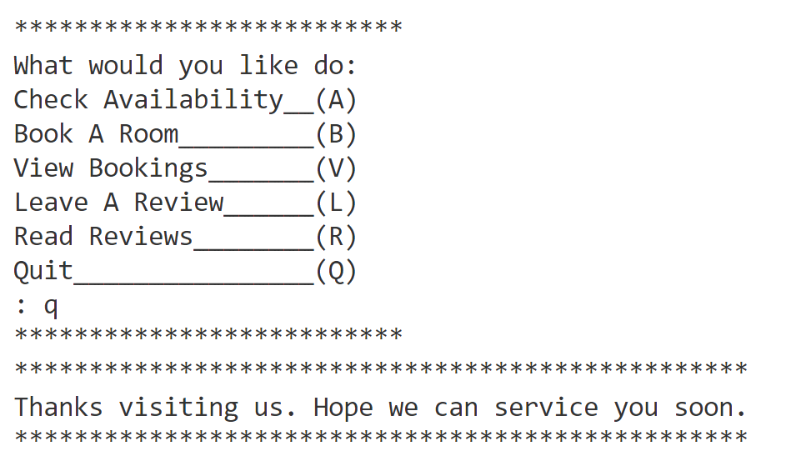

**Conclusion**

This hotel management project in python is the way to enhance and broaden our competencies and logic ideals which is essential in training the python programming language which is most suitable in lots of company.

The program helps in managing the checking the availability of the rooms, booking the rooms, viewing the booked rooms, leaving reviews and reading the reviews.

If there are no rooms available, we will get a message saying that no rooms available.

Thus, it will be helpful in easily managing the bookings, viewing them and leaving reviews.

**Bibliography**

* Computer science with python class

12-Sumita Arora

* [www.geeksforgeeks.com](http://www.geeksforgeeks.com)
* [www.tutorialspoint.com](http://www.tutorialspoint.com)
* [www.pythonworld.com](http://www.pythonworld.com)
* [www.reseqarchgate.net](http://www.reseqarchgate.net)
* <https://docs.microsoft.com>/
* <https://docs.python.org/>
* [www.javatpoint.com](http://www.javatpoint.com)
* [www.tutorialsteacher.com](http://www.tutorialsteacher.com)
* [www.datacamp.com](http://www.datacamp.com)